### United Solutions, LLC



GSA – EULA Challenge

User GUIDE

2020.08.13

### Your Name

## 1. Upload documents

landing page:



Select document(s) to upload, support .pdf, .doc and .docx:

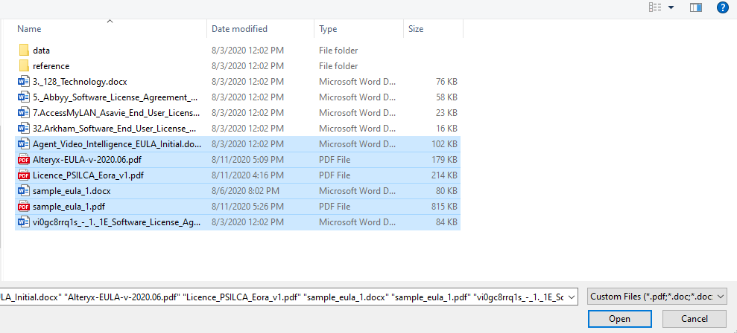

Confirm and upload documents:



## 2. View Results

Click on the predictions to modify:

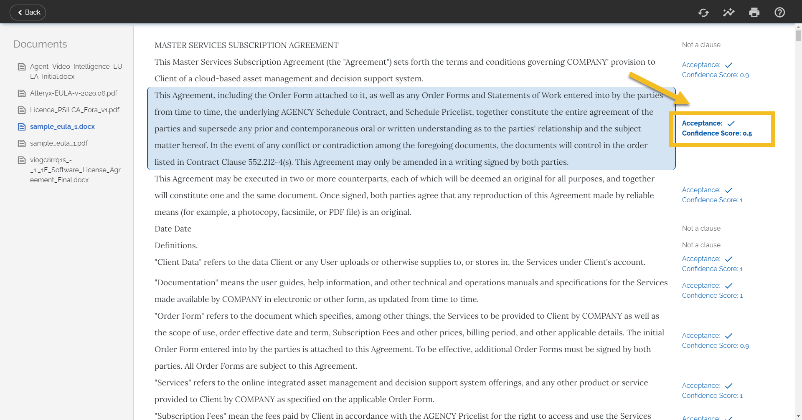

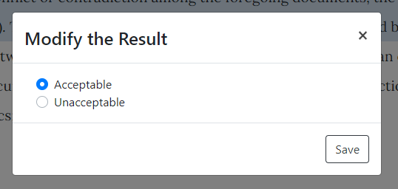

Retrain the model:

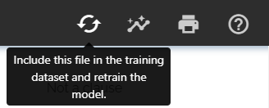

View insights about this document:

 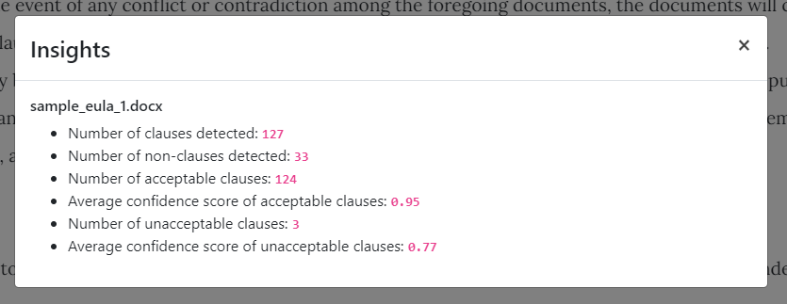

Print the page:



View tips:

 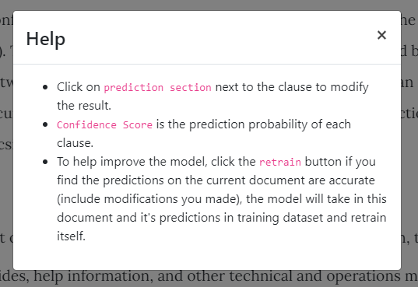

## Troubleshoot

If the user interface does not render correctly in your browser. And your click to the button has no response. Please check if you zoom in or out the page. Please make sure the page is in its original size.

If you still face this issue. You can try to click the red circle in the picture below to get the correct access.

